The Town of Crossfield Library Board

April 17, 2024

Location: Library Meeting Room

In attendance: Sherilyn King (via phone), Melissa Leech, Deanna McCormick, Lisa McNeil,
AJ Raffan, Brenda Rosvick, Jo Tennant, and Jennifer Warren
Absent: Janice Graham

Guest: Chelsey Devauld

Called to order at 7:02 pm

Land Acknowledgement
As we gather, we are reminded that the Crossfield Municipal Library is situated on the traditional territories of the Indigenous Peoples of the Treaty 7 region and Métis Nation of Alberta, Region 3. We respect the histories, languages, and cultures of First Nations, Métis, Inuit, and all First Peoples of Canada, and recognize the contributions they have made in shaping and strengthening our community. We are grateful for the opportunity to reaffirm our commitment to sharing Canadian Indigenous stories and creating a safe and welcoming space for all.

MOTION by Brenda to accept Agenda, VOTES all in favour
MOTION by Deanna to accept March Minutes, VOTES all in favour

Nicole Vandenberghe from FCSS dropped off Donut Man donuts for volunteer appreciation

Logo Design
- Chelsey Devauld of Chelsey Design met with us to review the process of designing a logo
- through the process we focused on the words Connecting, Scholarly, Learning, Dynamic, and Safe to describe what we want to convey about the library
Chelsey left at 8:18 pm

Board Duties
- Brenda separated responsibilities and tasks
- will forward the digital file to Jennifer to save on the library drive

Policy Revisions
- Deanna and Jo still working on it

Directors
- Canada Revenue Agency owners will be the executive directors and the library manager
  - MOTION by Brenda that Library Manager has access to CRA online instead of Treasurer, VOTES all in favour
  - Manager and Secretary to have access
- Charities Canada trustees are all the Board members
  - accountant changes this in June when doing the year-end financials, so can be a year out of date
  - Secretary to change the information as soon as a trustee joins or leaves the Board

Plan of Service
- nothing to update at this time

High Tea Fundraiser
- tablecloths and aprons will be rented through the Town’s account, so they’ll invoice us
- poster has been shared on social media and posted around town
- still need to collect some items like spreader knives
- 39 of 50 tickets have been sold
- setup will be Friday afternoon after 3pm, can get in at 10am on Saturday morning, clean up will be right after the tea is finished

AGLS
- 50/50 draw will be posted on the Shell sign May 9-20

Librarian’s Report
- there are no volunteer expectations from Board members as part of the Chamber of Commerce
- we are using our door count for data reports as it is more accurate that what Marigold has

Meeting adjourned at 8:38 pm. Next meeting will be on May 15, 2024.

SUBMITTED REPORTS
Librarian’s Report submitted by Jennifer Warren
Overview
- Everything has been sent off to the accountant.
- The Pink Wand has been hired for biweekly cleaning.
- Employee and volunteer evaluations have begun.
Programming
- Teen games has been having really good attendance lately!
- Program feedback forms were very positive.
- A new self-directed program, Creativity Saturdays has been added to the roster. It will run the last Saturday of each month 11-2.
Community Events & Library Space
- Another Bible Study group is now renting space on a monthly contract.
- Quite busy with rentals for birthday parties and a baby shower.
- CIP Grant – chair has been ordered, next looking to choose a new conference table.
Plan of Service
- Goal #1: Be an engaging and welcoming community hub.
  - Weeding in preparation of a book sale to run in the parade of garage sales.
  - Seed library & select garden tools headed to the Credit Union next week for a “Garden Party” community event.
- Goal #2: Provide life-long learning opportunities.
  - The new creativity Saturdays program includes ages 14+ in the hopes that craft knowledge can be exchanged.
  - Community Links Sign, Say, & Play program April/May.
- Goal #3: Encourage creativity and Imagination.
  - Logo update – I have started discussions with Chelsey Design about updating our logo.
  - The new craft program.
Donations & Fundraising
- The birthday fundraiser amounted to $105 and should be paid out soon.
- Another patron birthday Facebook fundraiser is underway!
- Received a $200 donation by cheque from a past resident of Crossfield.
Numbers
 | Checkouts | Patron Count | New Memberships
Feb | 1,733 | 1,170 | 18
Mar | 1,837 | 1,677 | 7

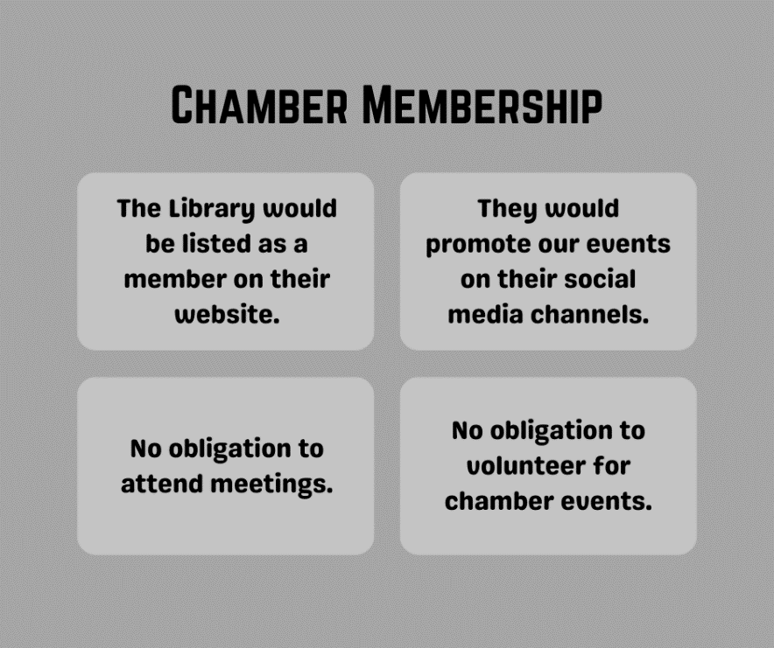
The following link offers some more information about the perks of being a chamber member https://www.abchamber.ca/get-involved/become-a-member/membership-benefits/

Financial Report submitted by Brenda Rosvick
- March financial reports, nothing unexpected

